Alex Antaki

Professor Rivas

CMPT 220

ID: 200-73-761

Software Development I

Homework 0

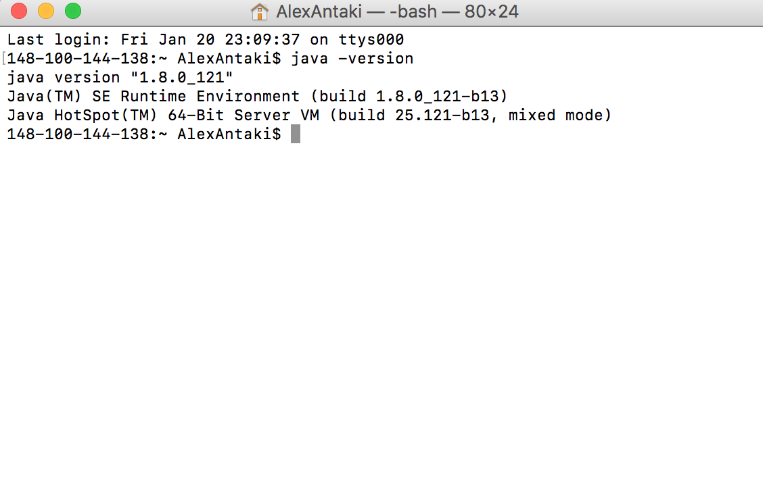

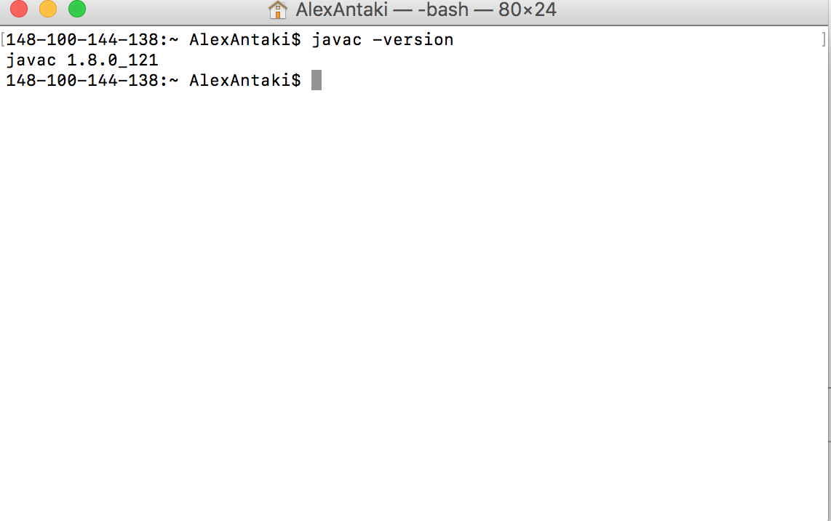

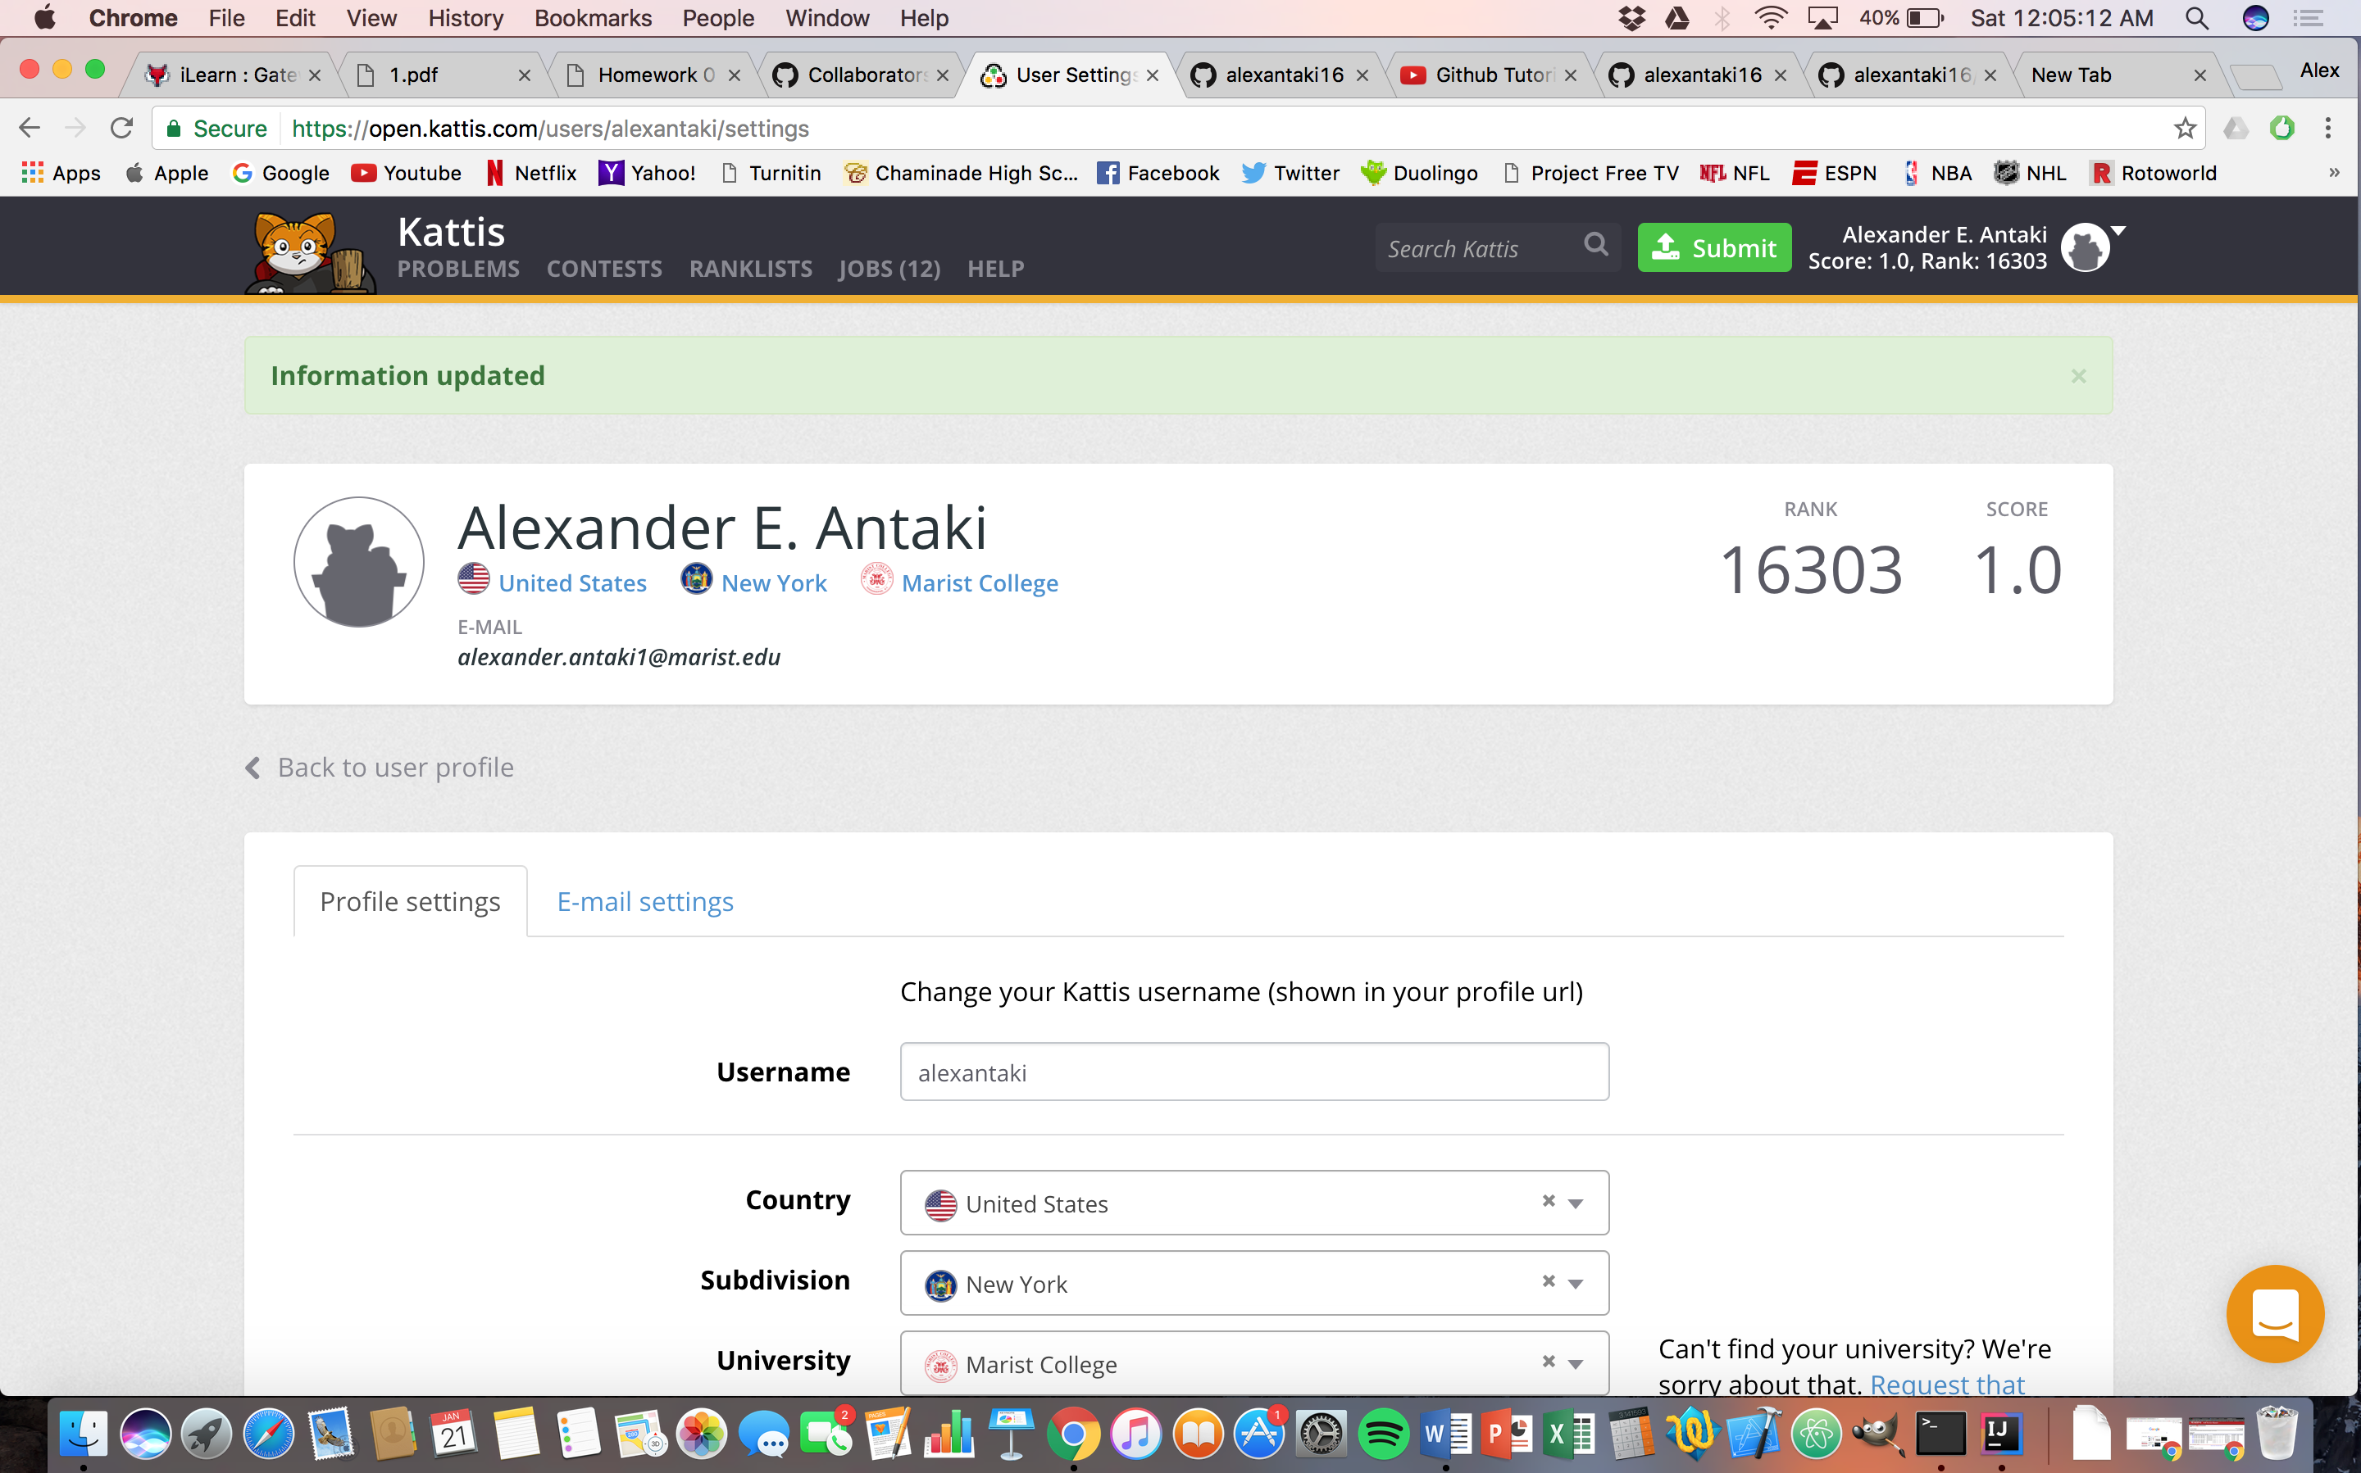

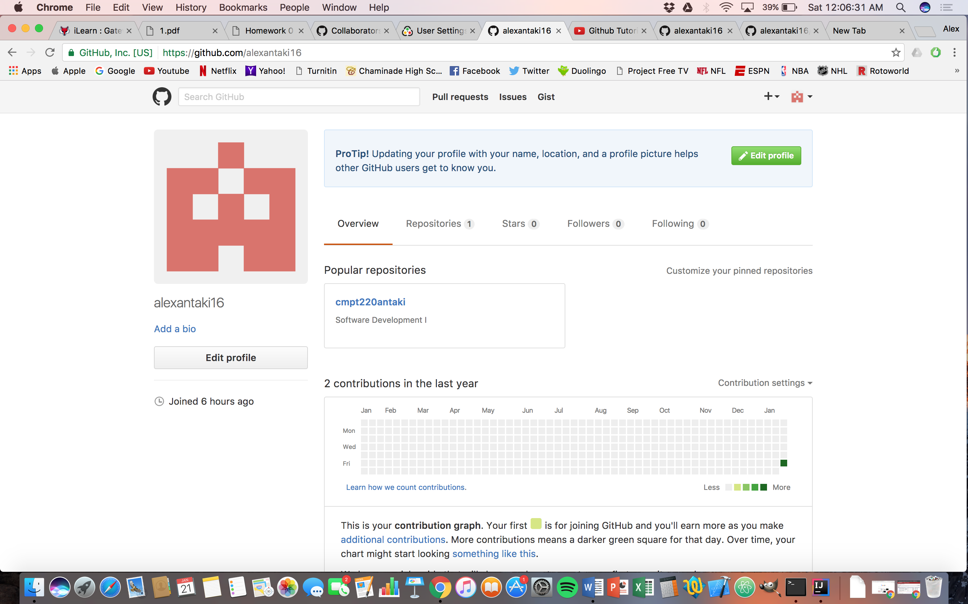

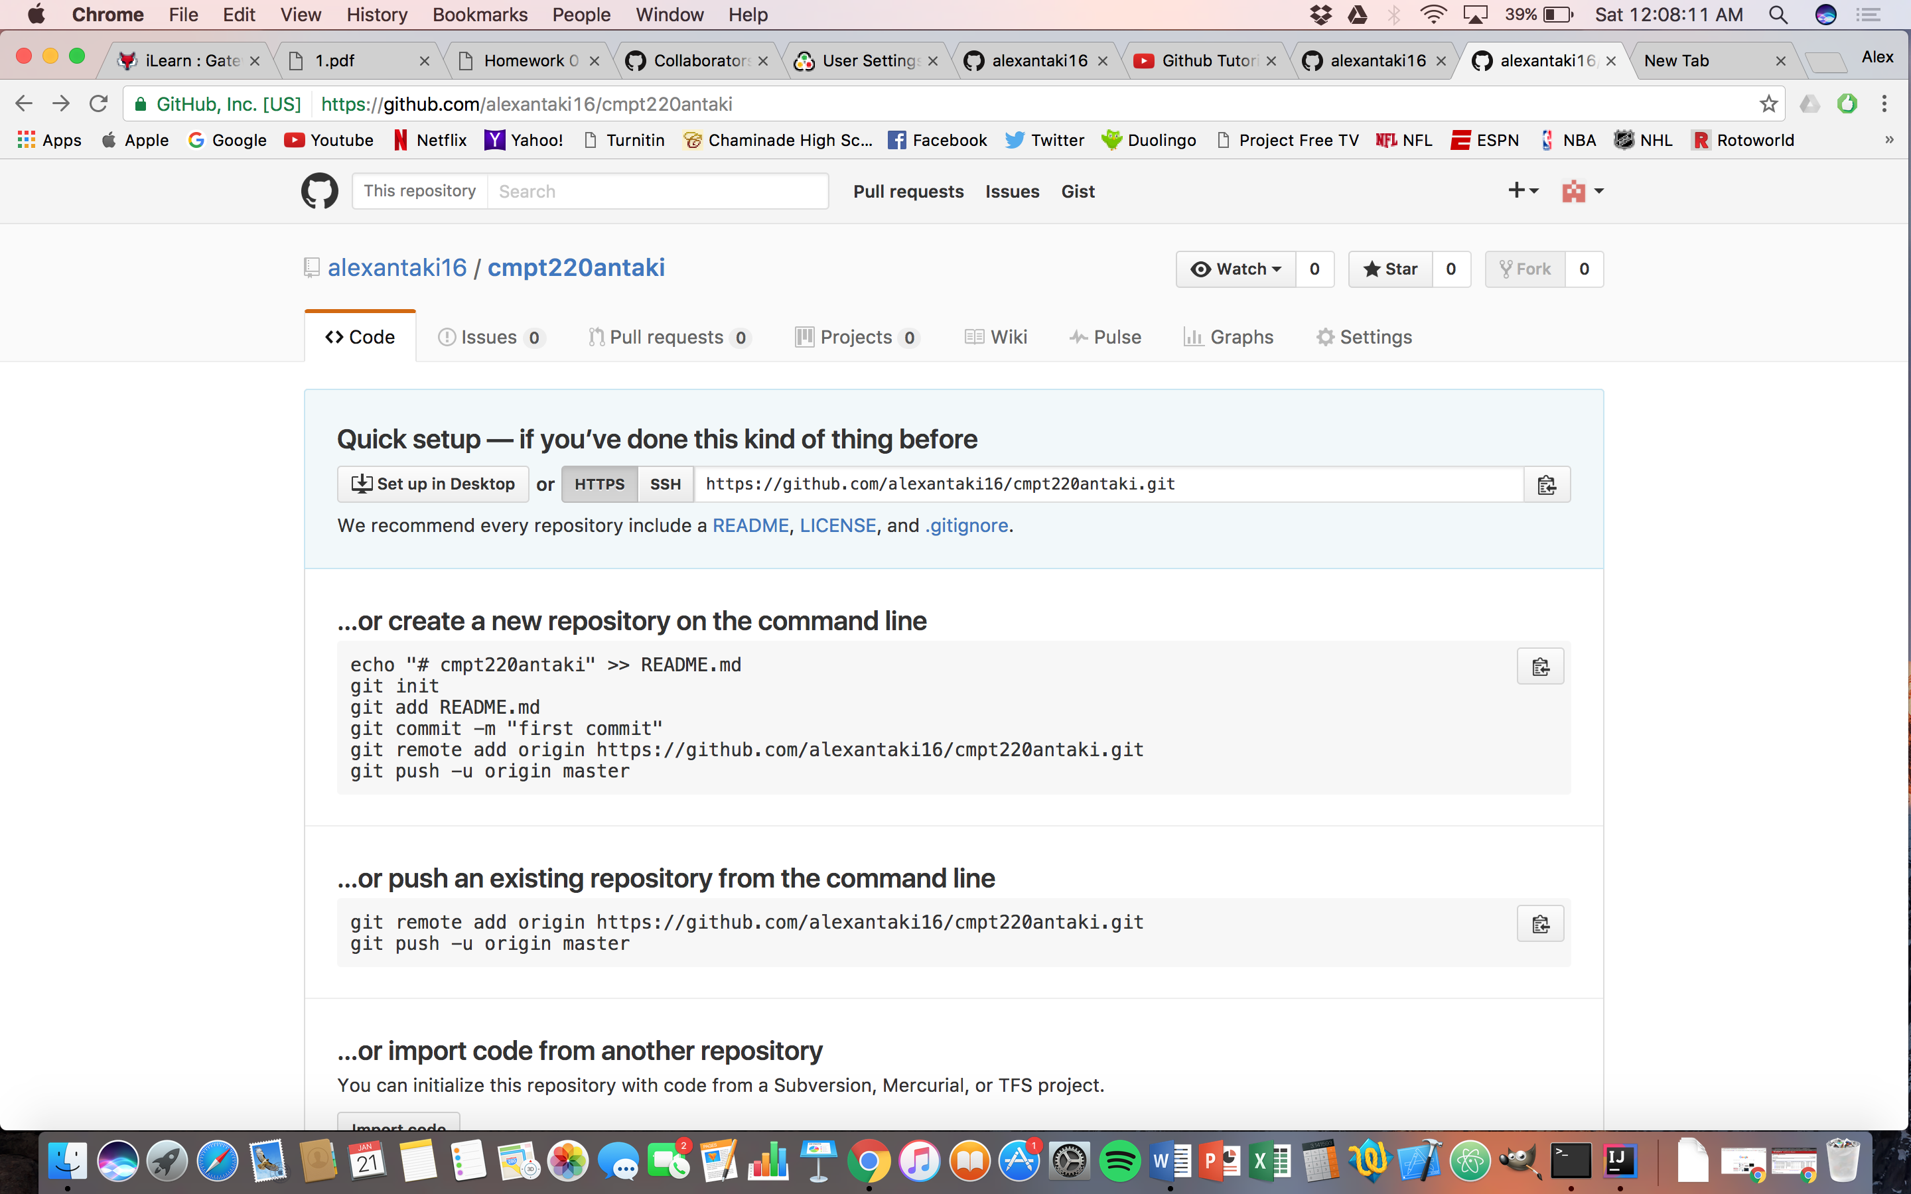

This is my repository link: <https://github.com/alexantaki16/cmpt220antaki.git>